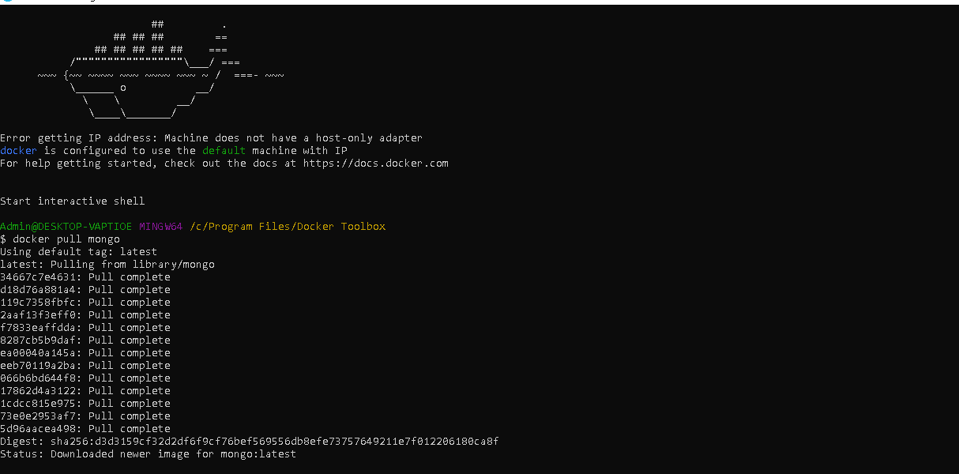

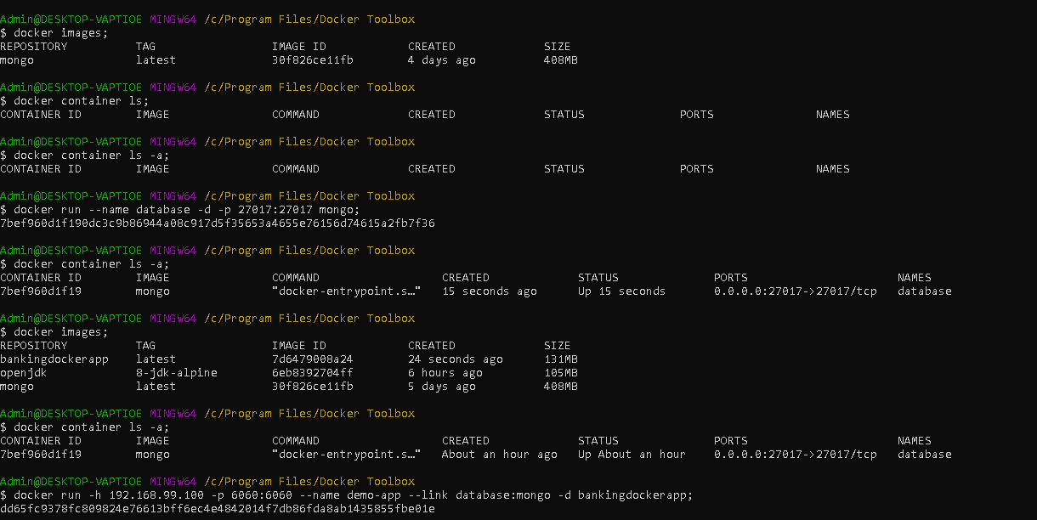

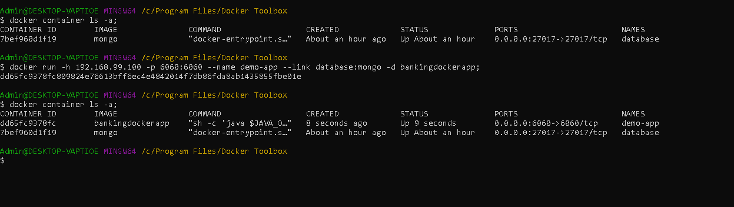

First open docker toolbox:

1. Then add mongo container to docker run below command:

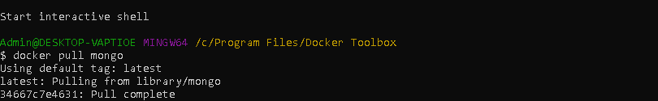

To confirm whether mongo container added run below cmd:

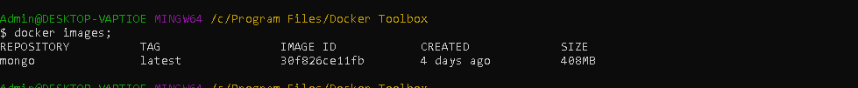

To run mongo db image



No we can see it has added and up:



No Next step is to build bankingdockerapp . go to bankingdockerapp class path and open cmd and type below command to build:

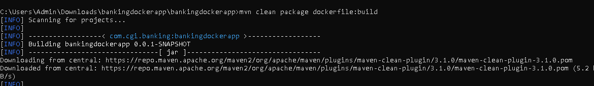

Once above build process success, again go to docker toolbox: and run below command:

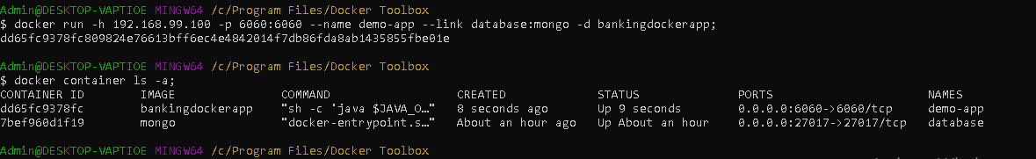

How to stop and remove all container from docker:

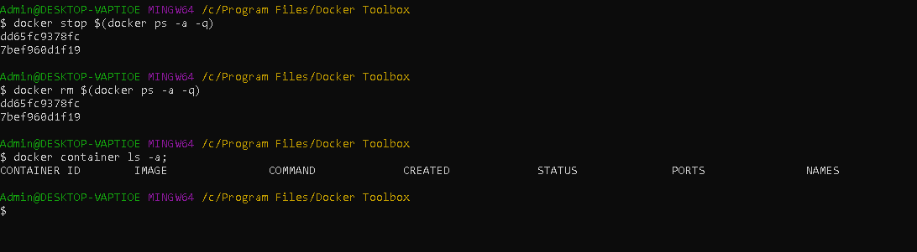

Docker-compose up

How to buid deploy image in one shot:

Go to project class path open cmd and run below cmd

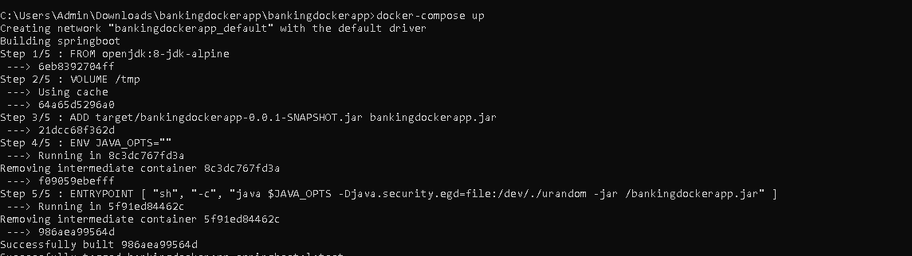

It will automatically do all step for us: and when we will run below command from docker tool box:

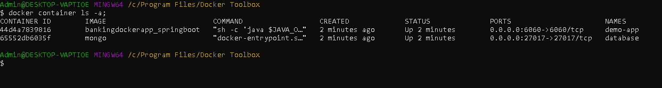

Application hosted on:

<http://rpscustomerapp.us-east-1.elasticbeanstalk.com>

FAQ- how to use same image for statging / QA

Docker Hub: create account

Vivekcbhardwaj

Viki@1234

Open docker toolbox and login to docker hub

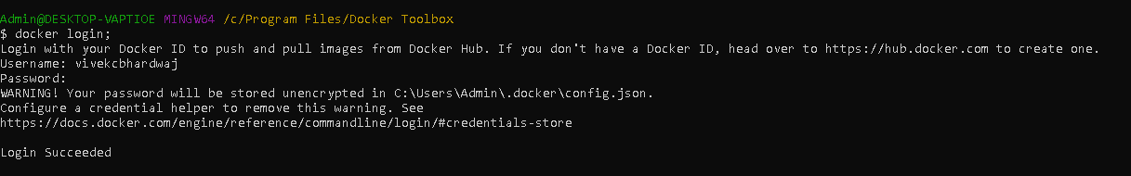

Then

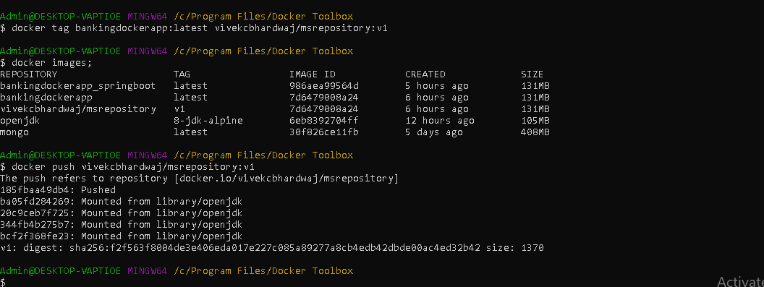

Docker tag bankingdockerapp:latest vivekcbhardwaj/msrepository:v1

Kubernate:

Install kuber